1. Spring Boot RESTful Microservice Deploy on AWS as well as use DynamoDB Demo
2. Configure DynamoDB inside AWS console
   1. First Go to AWS Console and go inside IAM service of AWS, Here we need to create the security policy for using DynamoDB.

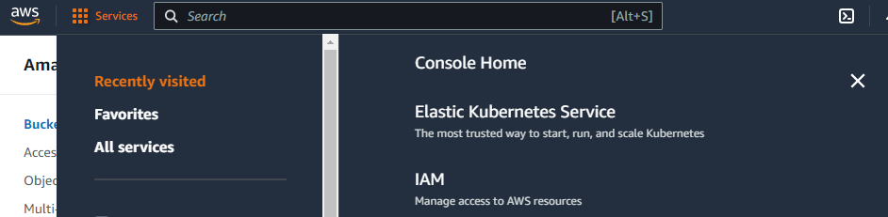

* 1. Inside IAM service go to Users Group and then click New Group button

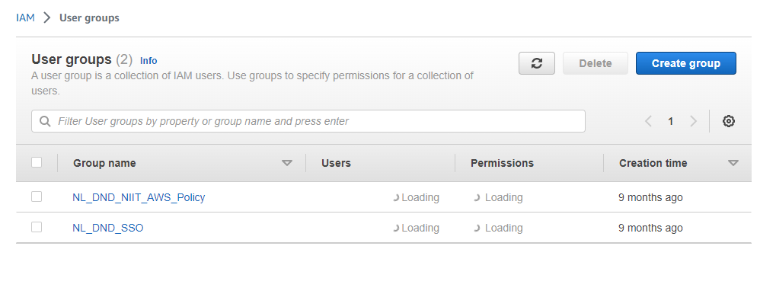

* 1. Give the group Name

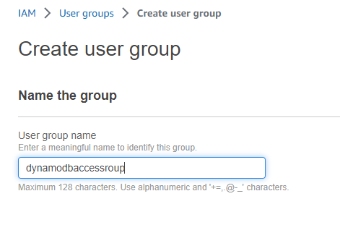

* 1. Now scroll down and attach policy name dynamoDBfullAccess policy.

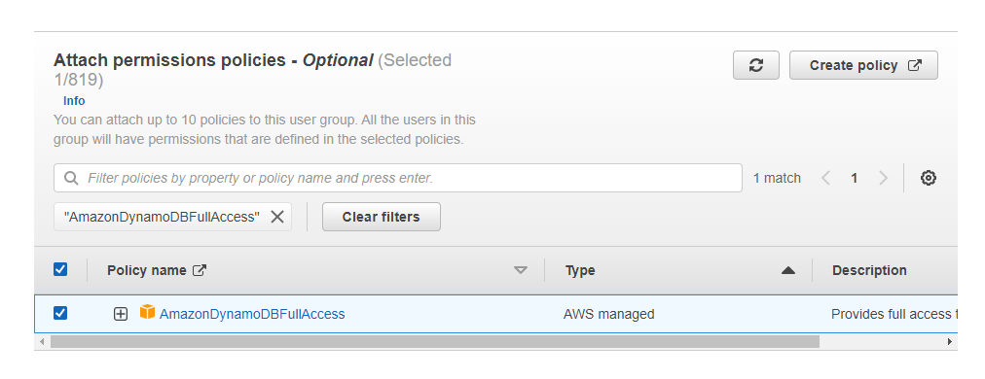

* 1. Now Click on Create Group Option and the group will be created

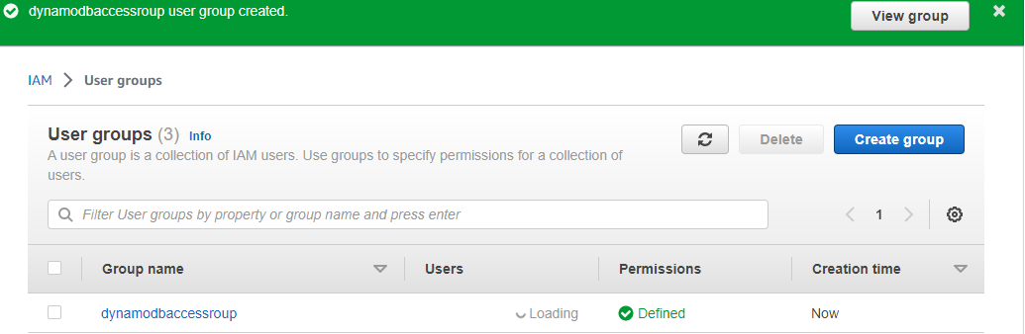

* 1. Now we will create users and add the users to this Dynamo DB access group. Select users and click the Add user button

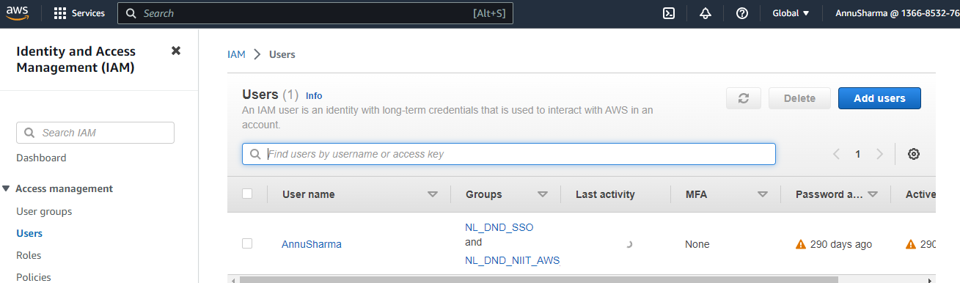

* 1. Now specify the user details and click Next button. Go ahead with the programmatic access which is default option.

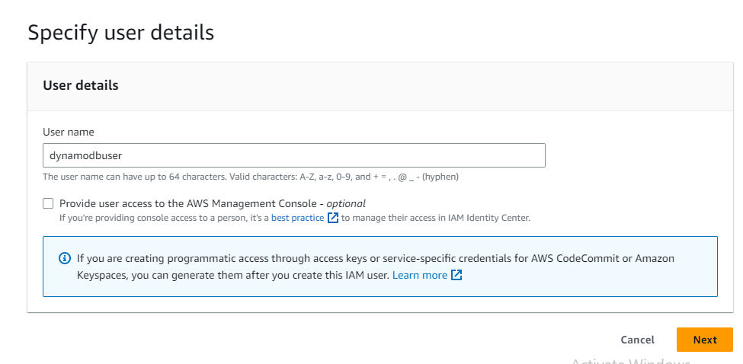

* 1. After you click Next button and then attach the user into the dynamDbaccess group which was created earlier.

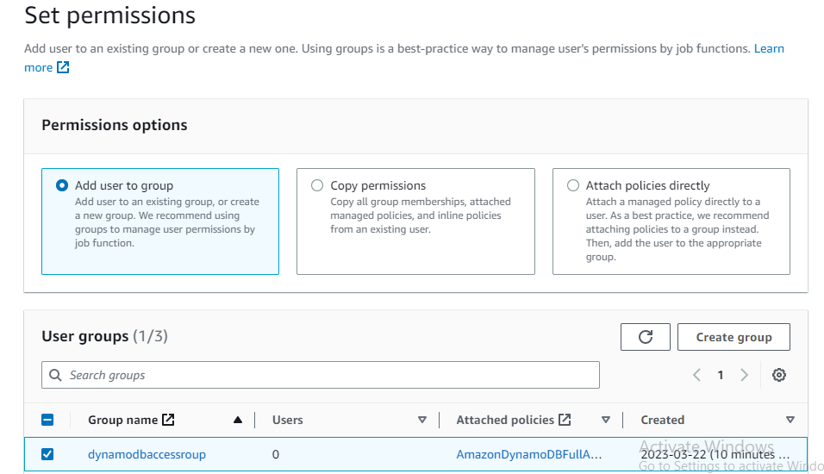

* 1. Click the next button again and then click the Create User button

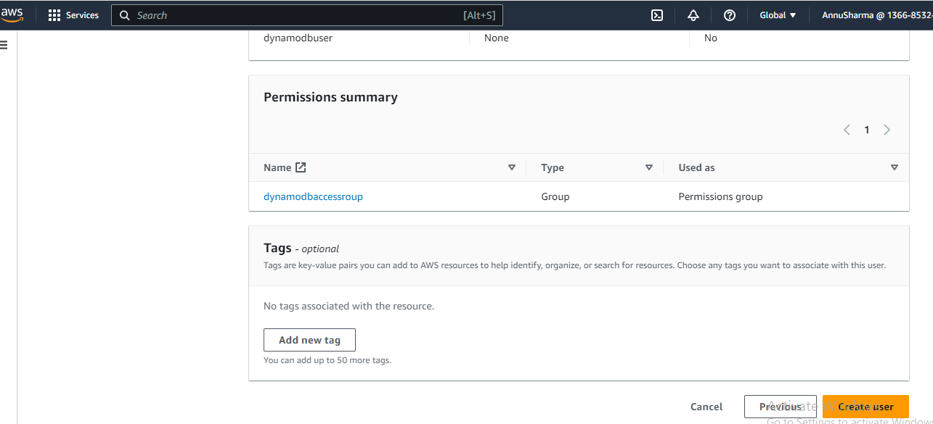

* 1. After that user will be created successfully

k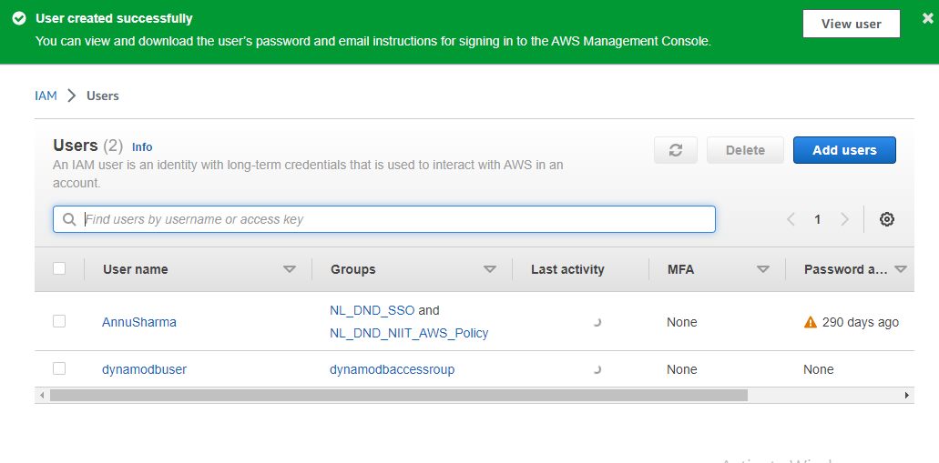

* 1. After this generate the accesskey and secretkey for this user.

1. Now create the DynamoDB table
   1. Select DynamoDB from the AWS services

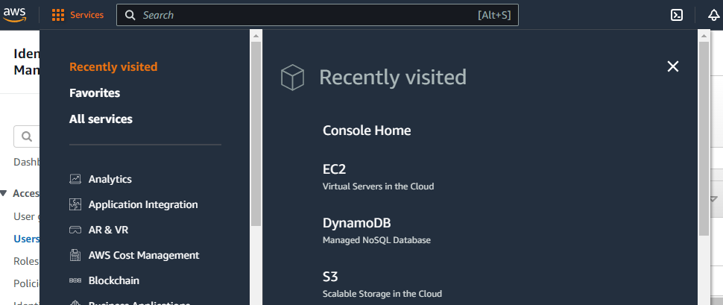

* 1. Now click Create Table button

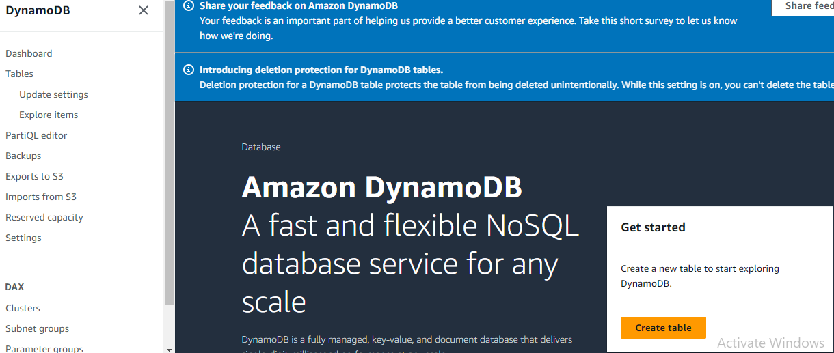

* 1. Now specify the Table details

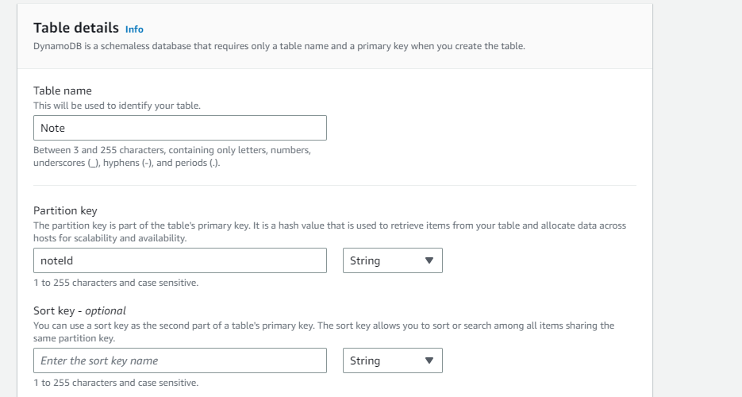

* 1. Now just click create table option with default settings.

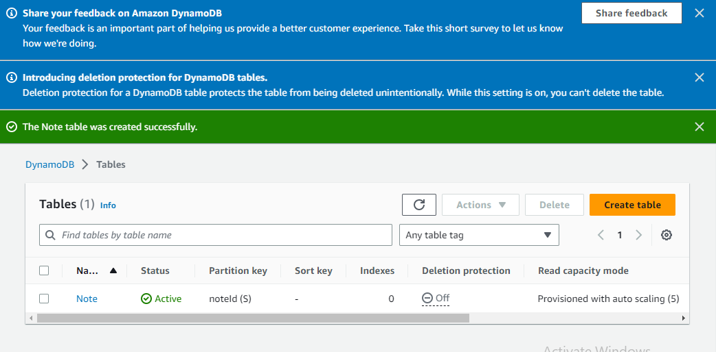

* 1. Now check the region details

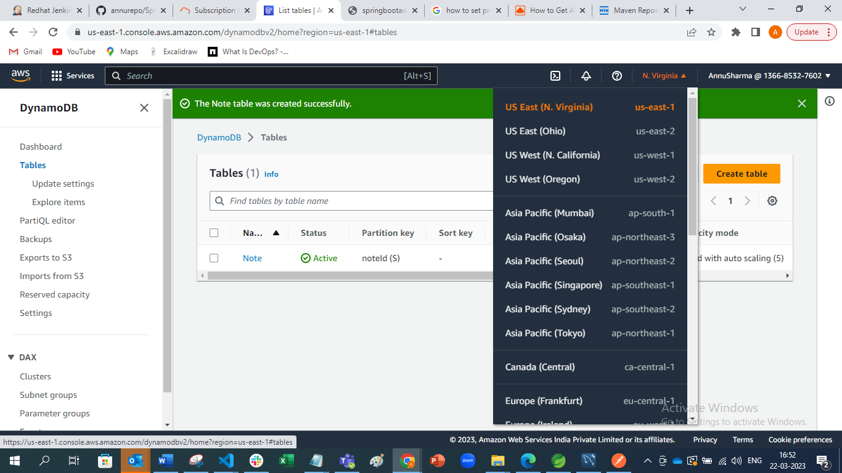

* 1. Go to spring application and specify the region inside the db url.

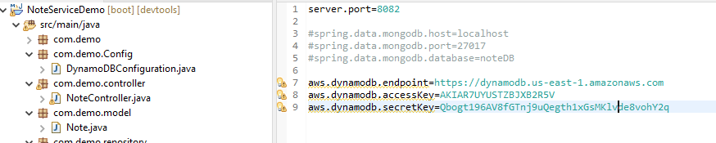

1. Now Test the application by using Post Man.

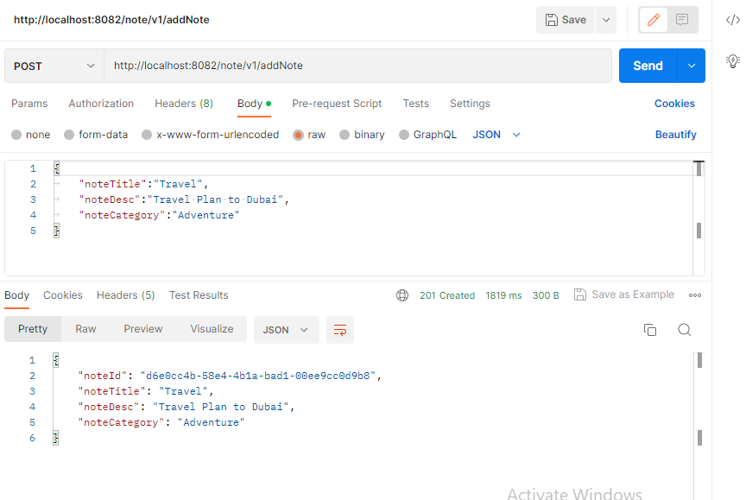

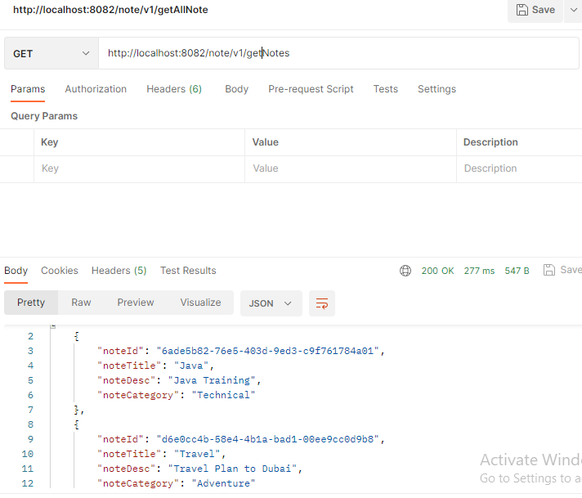

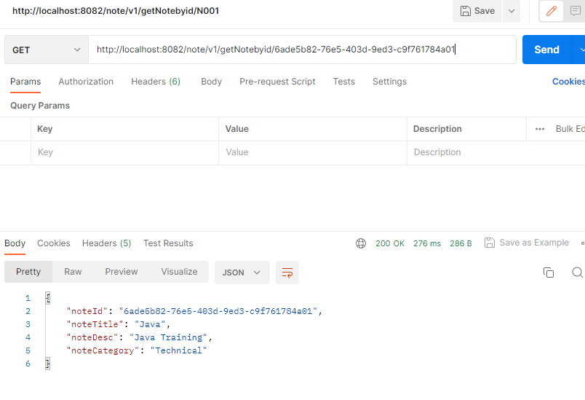

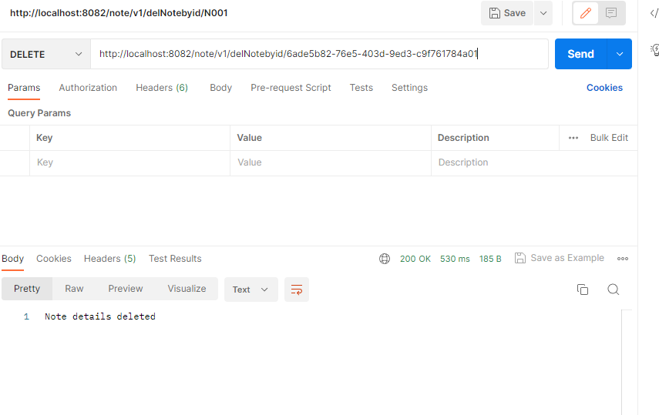

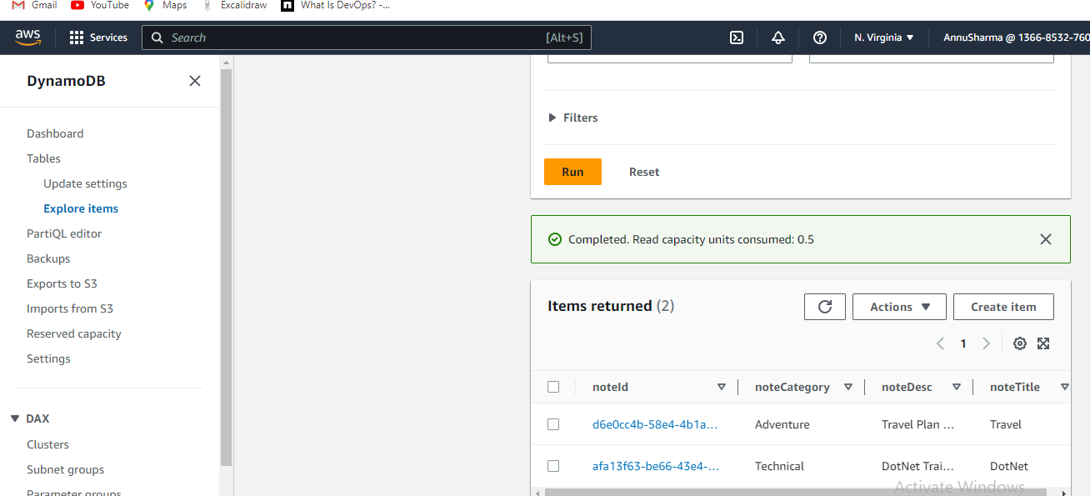

* 1. Now you can connect with database by clicking ok and implement Database queries.

1. Now go to spring boot application.properties file and change the database connectivity information.
   * 1. Replace the localhost with the endpoint URL provided by MYSQL instance created inside the AWS cloud.

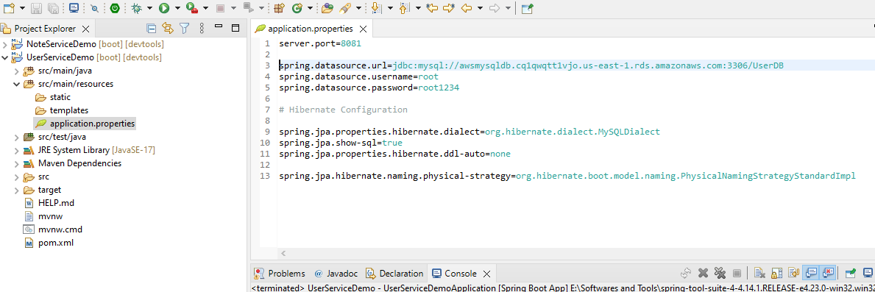

* 1. After that create the database inside the AWS RDS DB instance and then create table as well as Add few data for demo.

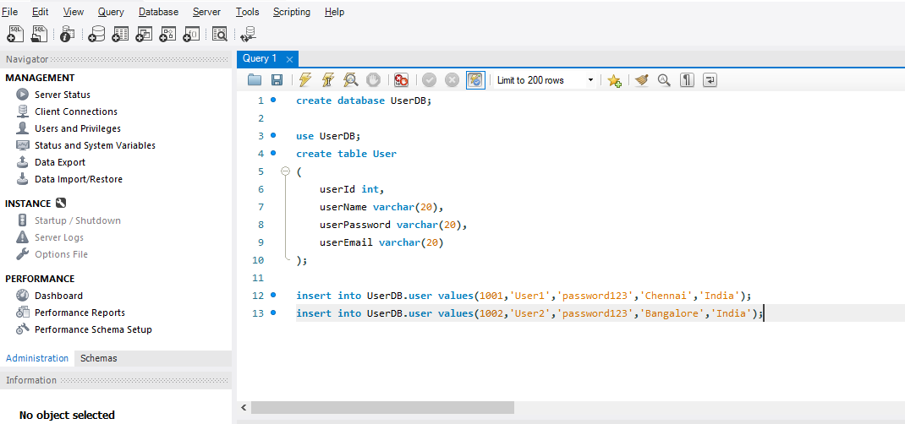

* 1. Now Test your SpringBoot application by running it locally first.

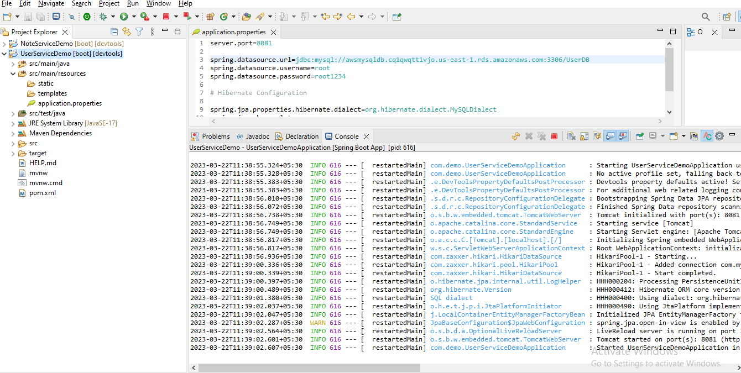

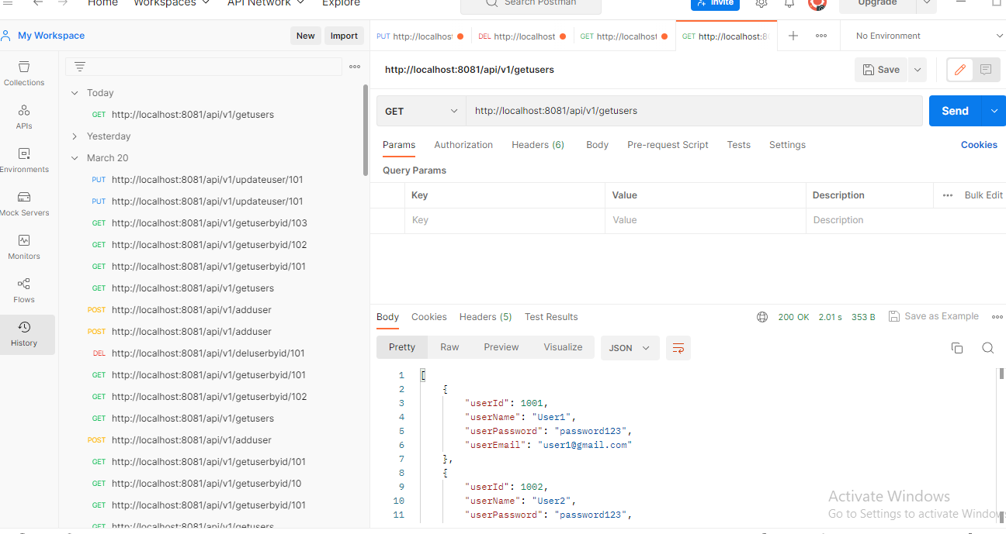

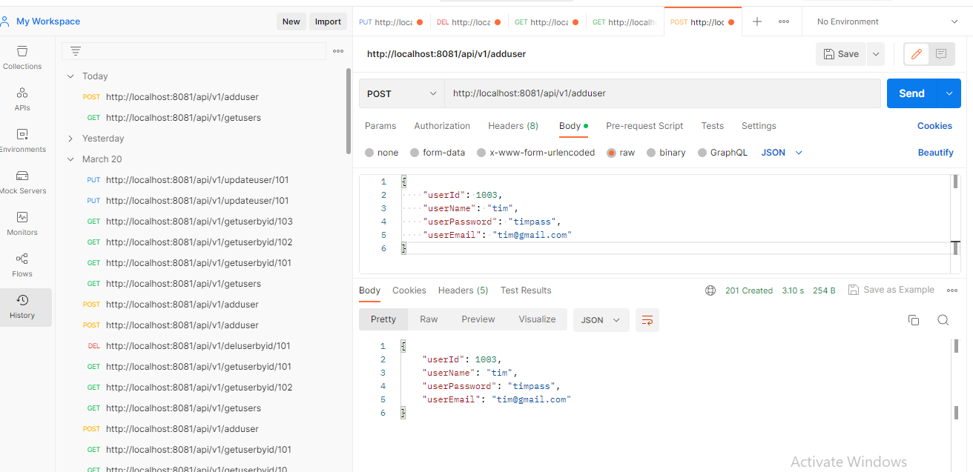

* 1. My SpringBoot Microservice is running fine in local machine. As you can see in above screen shots of postman.

1. Deploy the application in AWS EBS service
   1. First we need to change the port to 5000 because EBS expect the springboot application to listen port 5000.

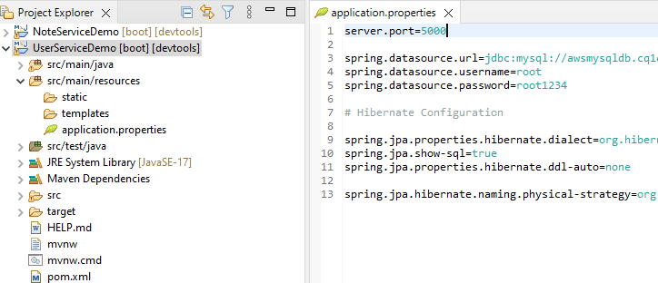

* 1. Package SpringBoot Application as JAR file
     1. Run the command mvn clean
     2. Run the command mvn build
     3. After this JAR file will be generated which we can use for deployment

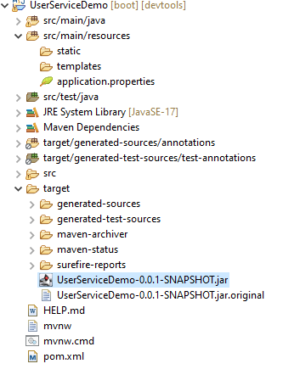

1. Deploy SpringBoot JAR file on AWS using Elastic beanstalk service
   1. Go to AWS Console and choose EBS service

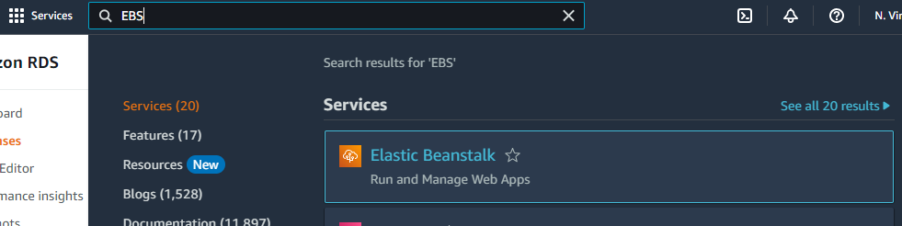

* 1. Now click create application

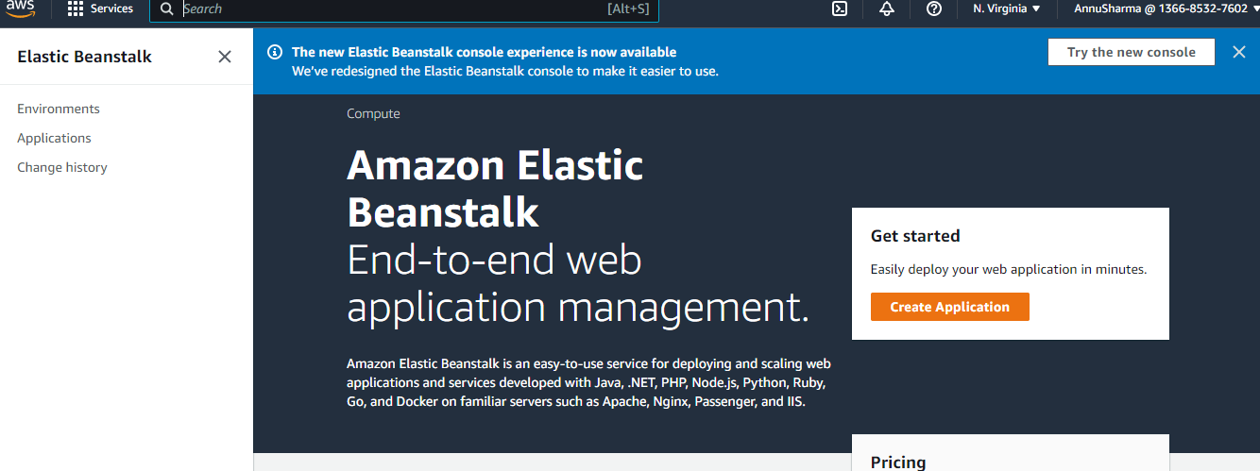

* 1. Give application name

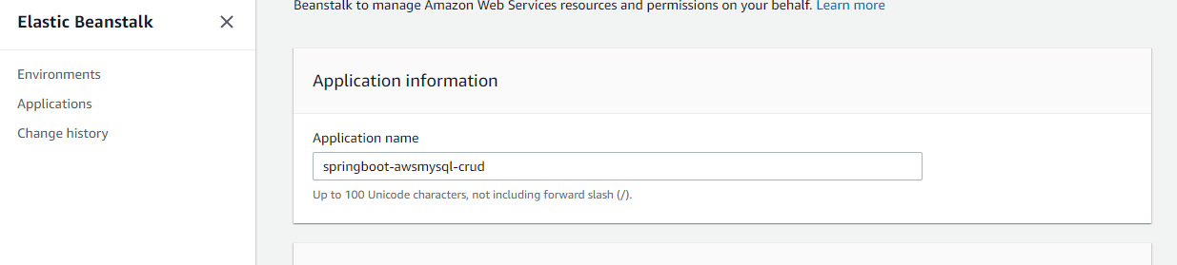

* 1. In platform choose Java

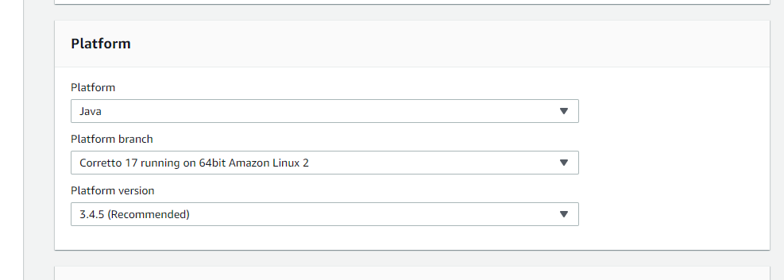

* 1. Now choose the option upload your code

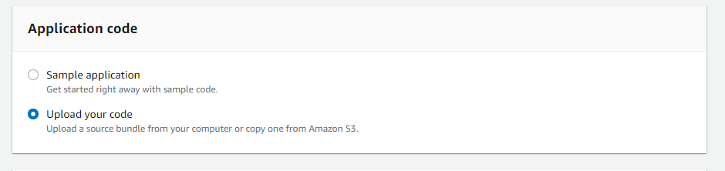

* 1. Click choose file and then upload the JAR file created for your Spring boot application

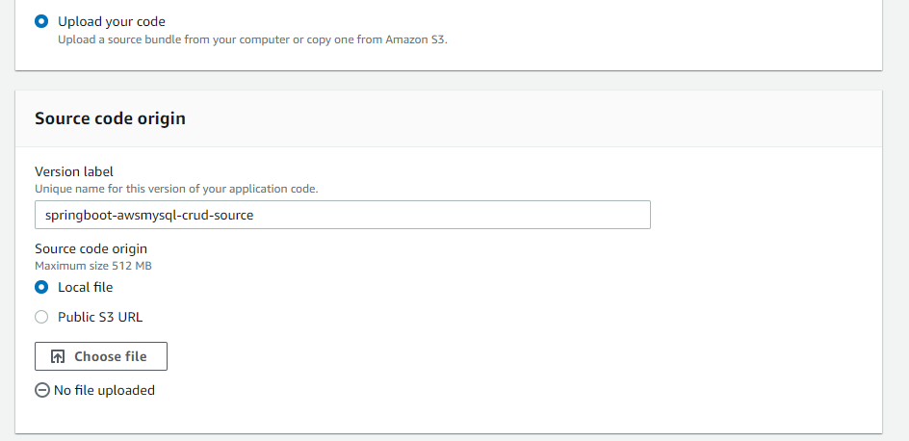

* 1. Go to JAR file path and then select the JAR file to upload

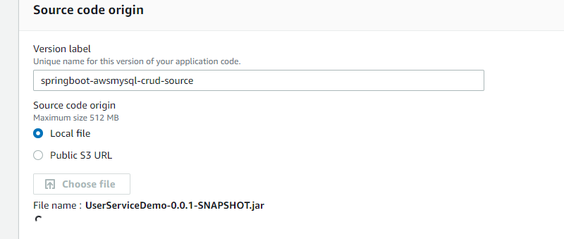

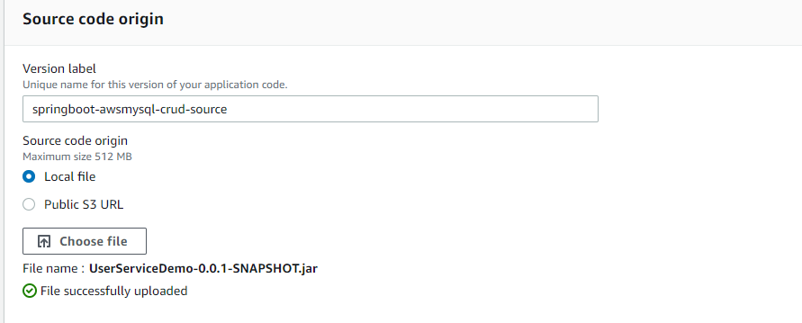

* 1. Now the JAR file uploaded successfully. EBS service will provide all the resource which is required to run spring boot application. Behind the scene it will create EC2 instance and S3 bucket and it will upload the Jar file inside the S3 bucket.
  2. Now click in Configure More Options and then go to Database options and then click on EDIT. Here provide the username and password for your database.
     1. root
     2. root1234

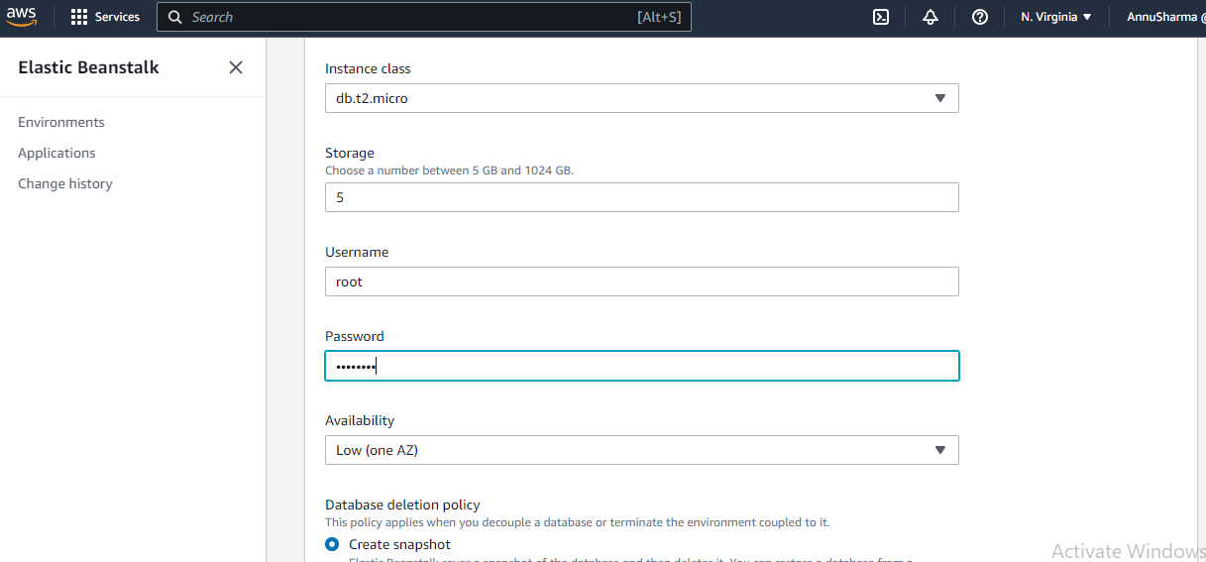

* 1. Now Click Save button
  2. After that Click the “Create App” button

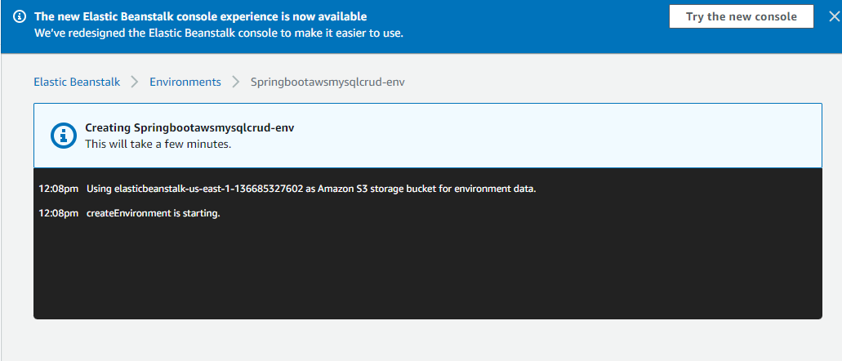

* 1. Now it will setup the environment to run the application

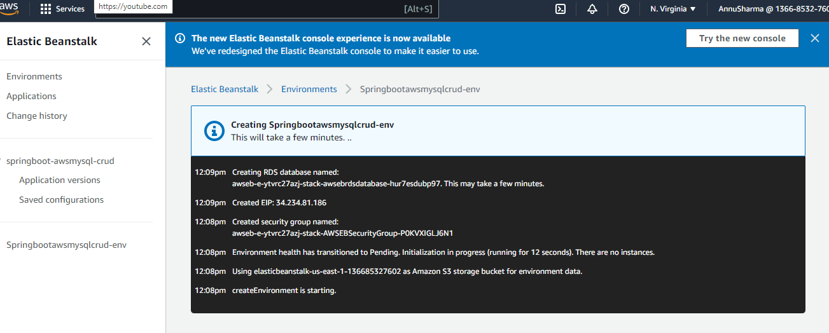

* 1. Application creation will take some time and once it is successfully deployed it will provide the link which can be used to work with the application.

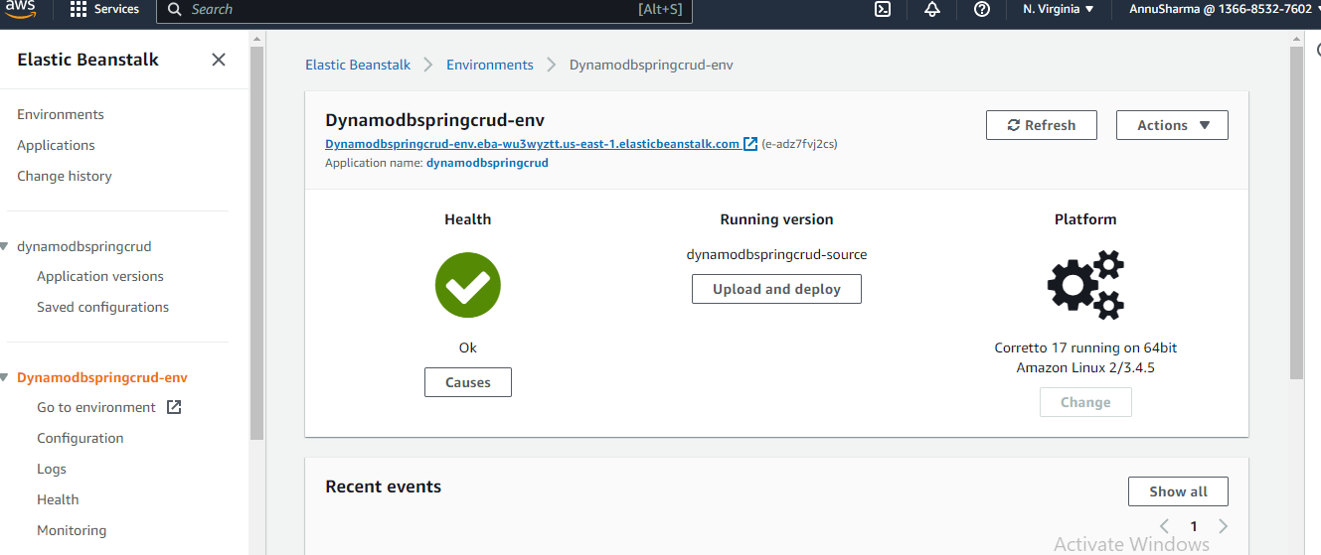

* 1. Now you can test the application by using the URL provided
     1. http://dynamodbspringcrud-env.eba-wu3wyztt.us-east-1.elasticbeanstalk.com/

1. Test over POSTMAN client now.

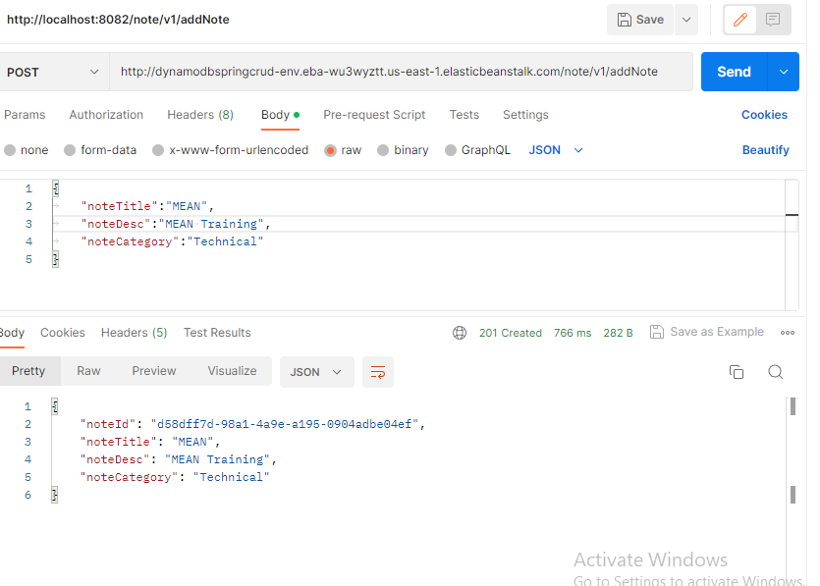

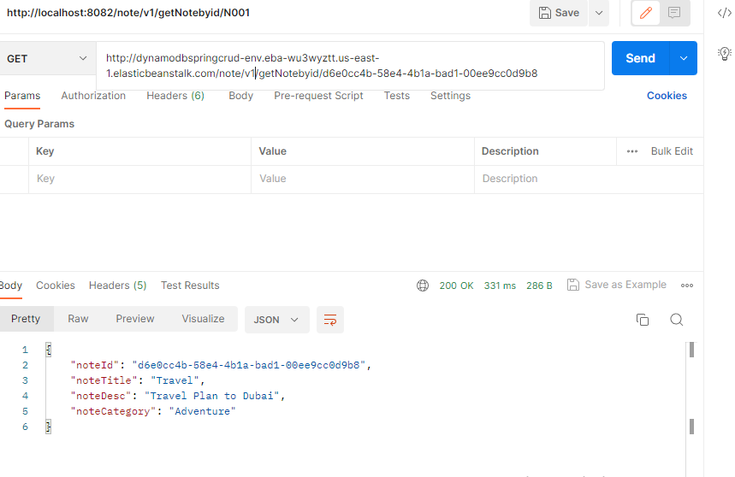

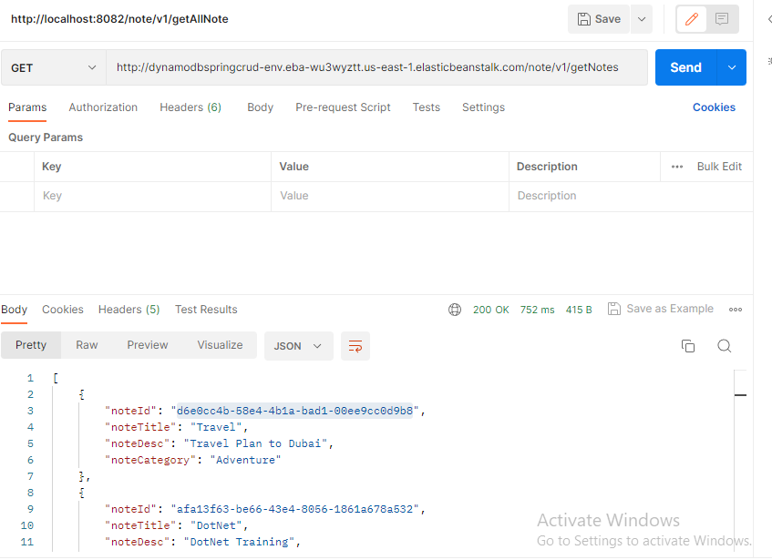

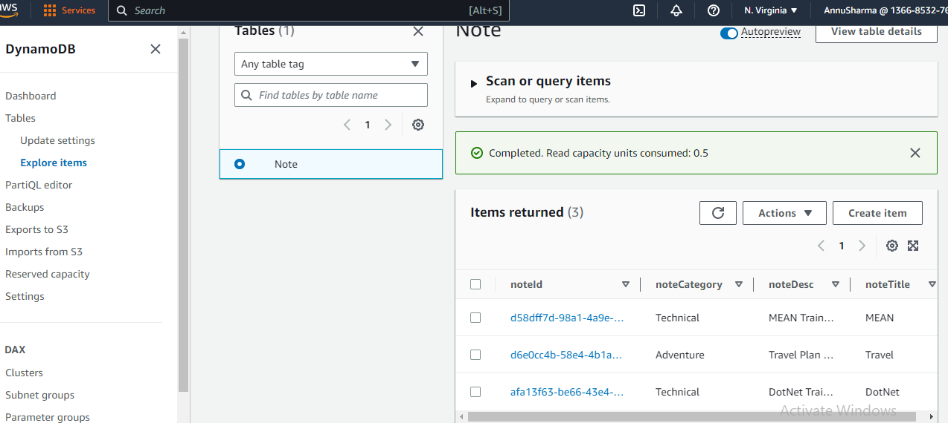

1. Thank you..

For reference

* 1. Now the JAR file uploaded successfully. EBS service will provide all the resource which is required to run spring boot application. Behind the scene it will create EC2 instance and S3 bucket and it will upload the Jar file inside the S3 bucket.

